MEDIA REQUEST FORM 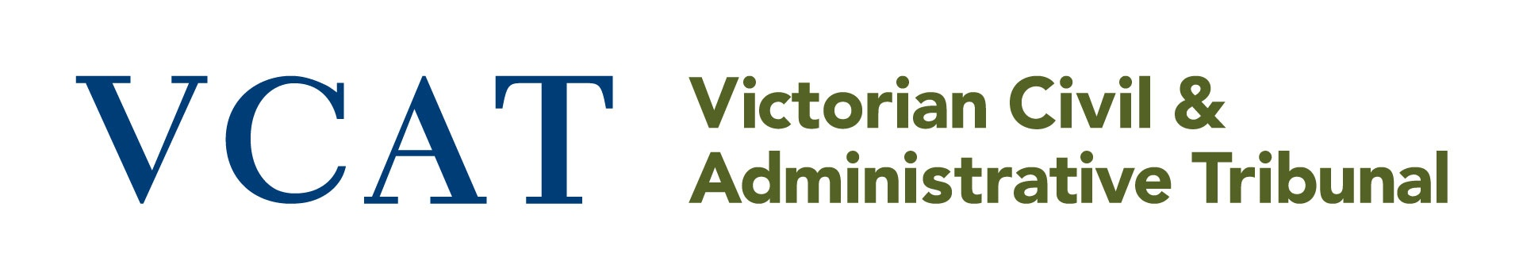
MEDIA USE ONLY
 | Contact details
 | Name
 | Organisation
 | Phone number
 | Complete this section if requesting file access or a copy of a decision
 | VCAT List
 | Tick which VCAT List the proceeding is in |  | Building and Property
 |  |  | Civil Claims
 |  |  | Guardianship
 |  |  | Human Rights
 |  |  | Legal Practice
 |  |  | Owners Corporations
 |  |  | Planning and Environment
 |  |  | Residential Tenancies
 |  |  | Review and Regulation
 | You must complete at least one of the fields below
 | VCAT reference number
 | Name of all parties
Site address
- if the case is about land. Eg. A planning, building or land valuation dispute.
 | Payment
 | Request type |  | File inspection $128.80 (corporate or standard fee payer)
 |  |  | Register inspection $79.50 (corporate or standard fee payer)

Email your completed form to media@vcat.vic.gov.au. Contact the Strategic Communications team on 0400 289 429 to discuss your request and arrange payment by VISA or Mastercard. Do not email credit card details.

